Assignment: 2

Name: Deepa
Registration Number: 20BCI0116
Campus: Vellore

Assignment: Bash Shell Basics

Task 1: File and Directory Manipulation:
- Create a directory called "my_directory".
- Navigate into the "my_directory".
- Create an empty file called "my_file.txt".
- List all the files and directories in the current directory.
- Rename "my_file.txt" to "new_file.txt".
- Display the content of "new_file.txt" using a pager tool of your choice.
- Append the text "Hello, World!" to "new_file.txt".
- Create a new directory called "backup" within "my_directory".
- Move "new_file.txt" to the "backup" directory.
- Verify that "new_file.txt" is now located in the "backup" directory.
- Delete the "backup" directory and all its contents.

Output:
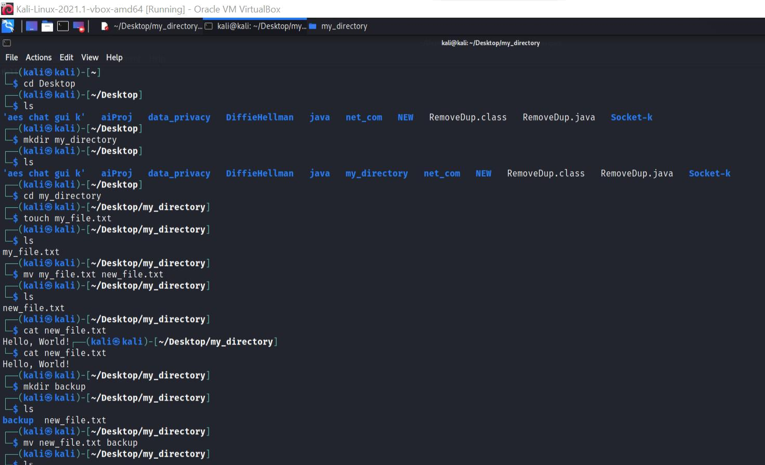

.
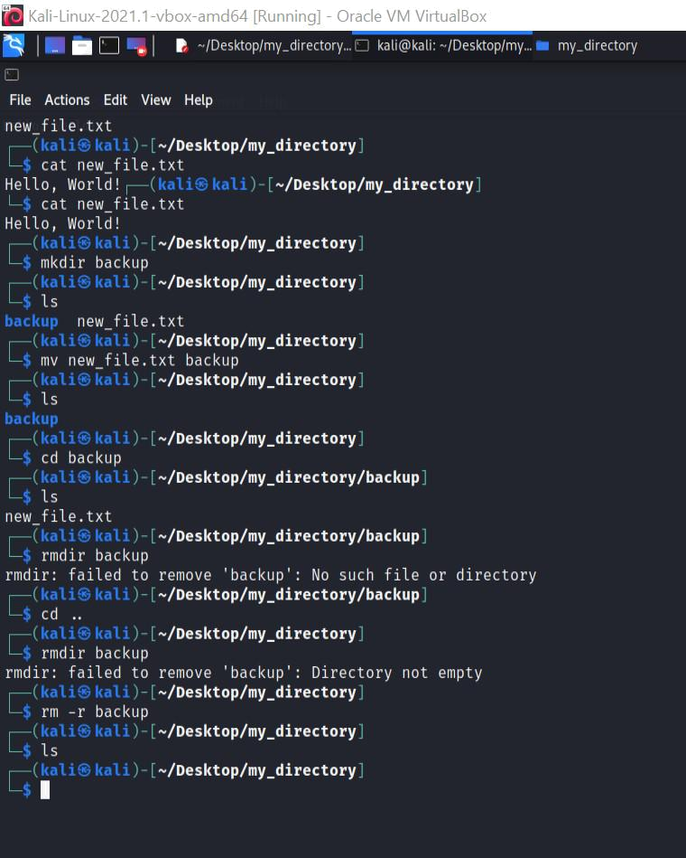

.

Task 2: Permissions and Scripting:
- Create a new file called "my_script.sh".
- Edit "my_script.sh" using a text editor of your choice and add the following lines:
bash #!/bin/bash
echo "Welcome to my script!" echo "Today's date is $(date)." Save and exit the file.

- Make "my_script.sh" executable.
- Run "my_script.sh" and verify that the output matches the expected result.

Output:
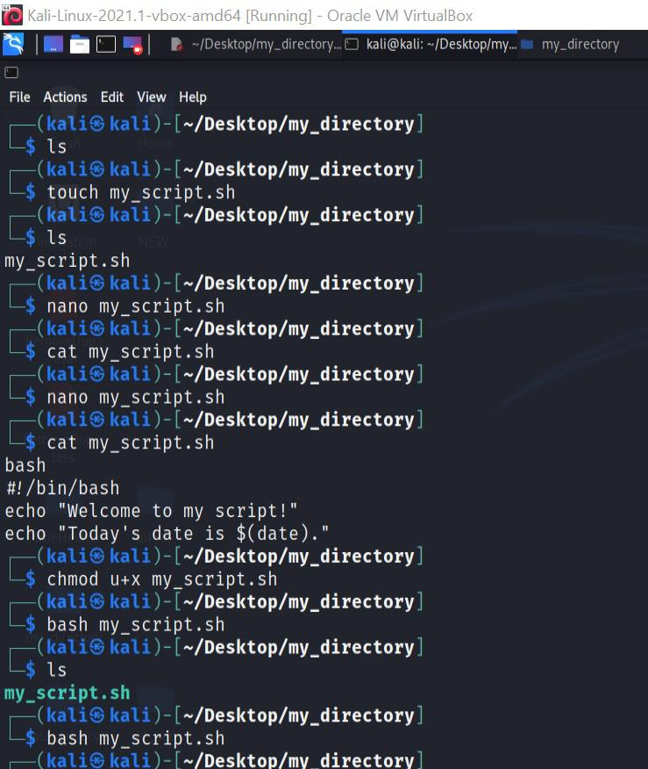

.

Task 3: Command Execution and Pipelines:
- List all the processes running on your system using the "ps" command.
- Use the "grep" command to filter the processes list and display only the processes with "bash" in their name.
- Use the "wc" command to count the number of lines in the filtered output.

Output:
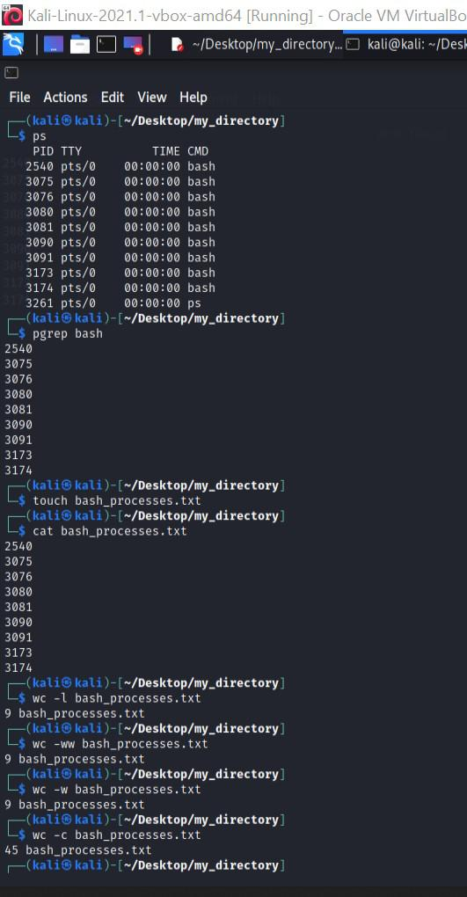

.

THANK YOU!!!

